12. Motor Systems *Chapters 38, 43*

______________________________________________________________________________

I. Introduction *(1016-1017, 1023-1025)*

A. Output Messages

B. Skeletons and Muscles

1. Hydrostatic skeletons

2. External skeletons

3. Internal skeletons

II. Components of Vertebrate Systems *(917-920)*

A. Bone

B. Cartilage

C. Tendons and Ligaments

D. Muscles

1. Smooth muscle

2. Skeletal muscle

3. Cardiac muscle

III. Muscle Action *(1017-1018, 1025-1027)*

A. Antagonism of Paired Muscles

B. Response of Single Muscles

1. Whole muscle graded response

2. Muscle fibers and innervation

3. Time course of contraction

4. Summation

IV. Molecular Basis of Muscle Contraction *(1017-1023)*

A. Fine Structure of Skeleta; Muscle

1. Fibers

2. Bundles

3. Sarcomeres

B. Sarcomere Anatomy

1. Distinctive zones

2. Distinctive biochemistry

C. Sarcomere Action

1. Telescoping of components

2. Changes in the zones

3. Sliding filament theory

4. Mechanism of sliding

5. Innervation and control of sliding

12-1

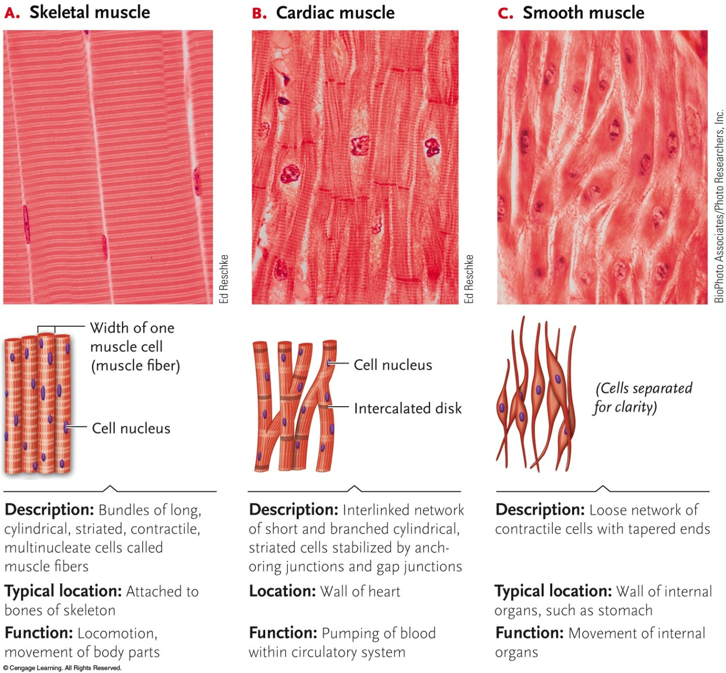12-2

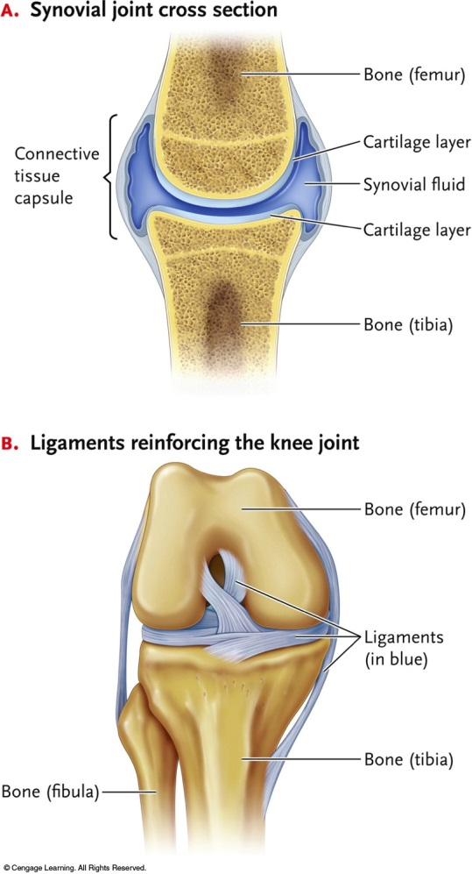

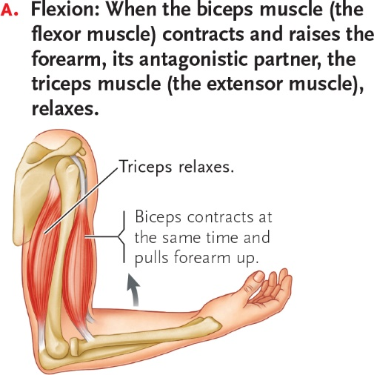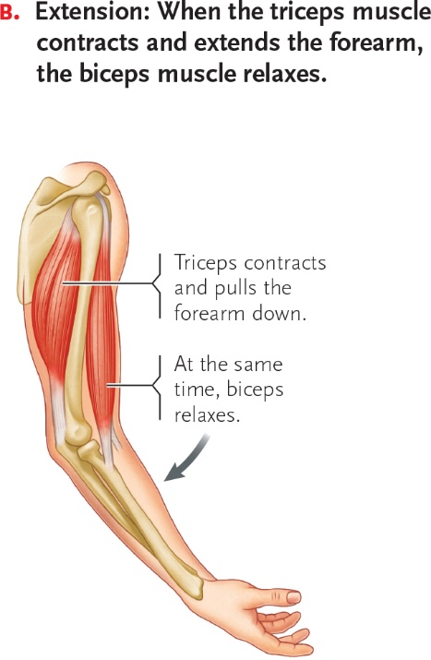

12-3

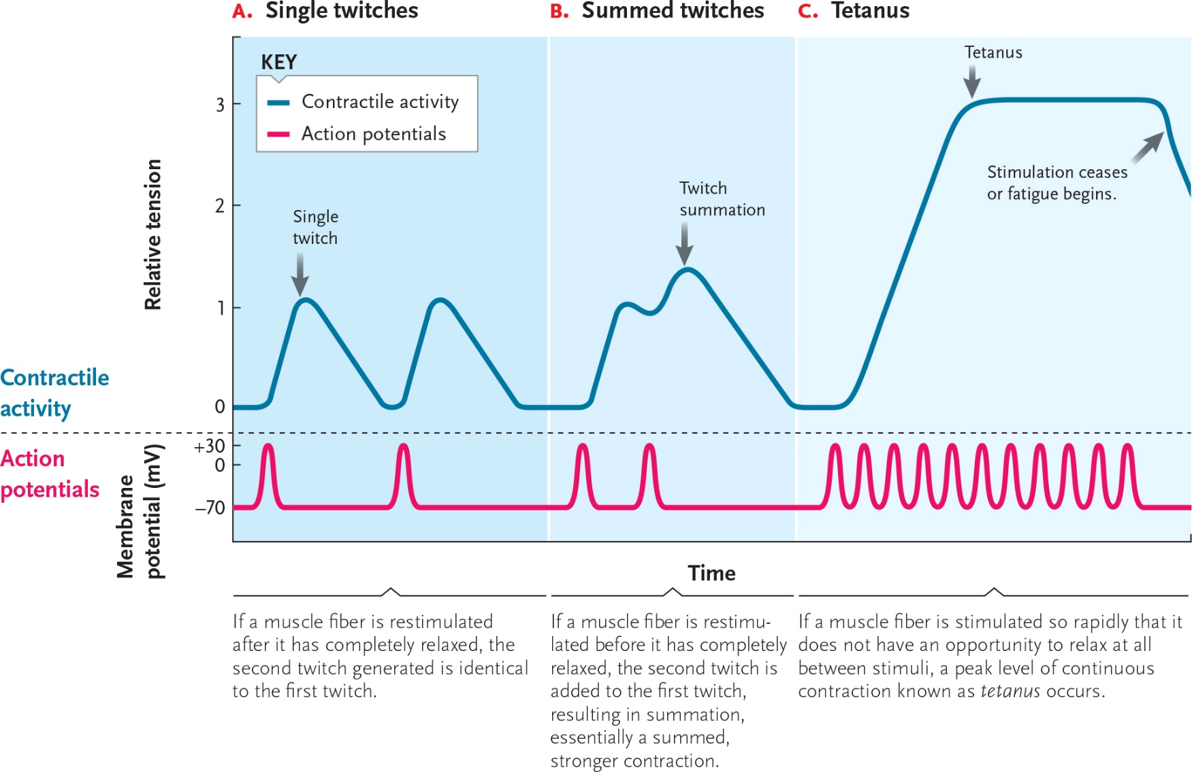

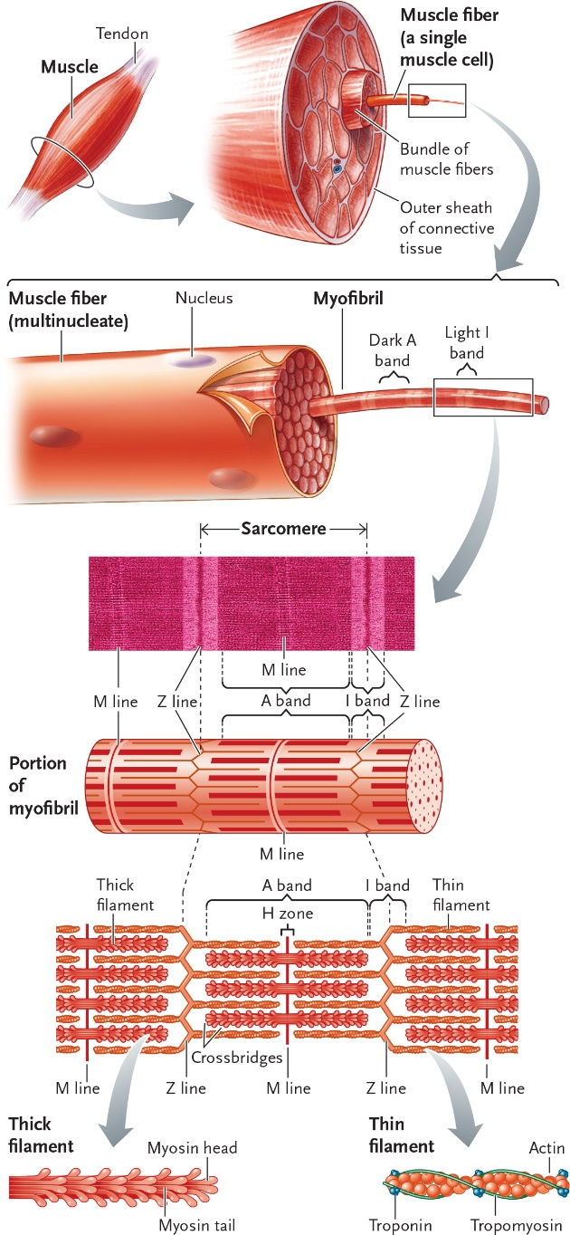

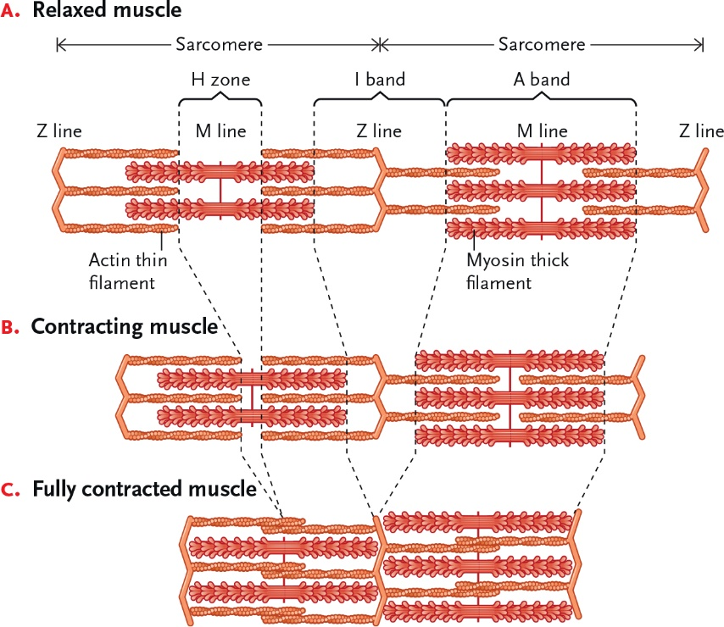

12-4

12-5

